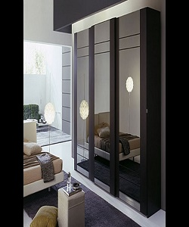

Cupboard

$156.86

Availability: In stock

Description

This chair turn you room into the Centre of attention. This Cupboard also accommodates UK standard size. With its curvaceous contours surface, the cupboard gives fashionable look to your room.